EXPERIMENT – 6

EXP No: 6

Date: ___________

Title
BETWEEN, IN and Aggregate Functions (COUNT, SUM, AVG, MIN, MAX)

AIM
To perform BETWEEN, IN, and Aggregate Functions on the Drone Delivery Management System database.

DESCRIPTION
The BETWEEN operator retrieves values within a specified range. The IN operator checks whether a value exists in a list. Aggregate functions perform calculations on multiple rows and return a single value.

PROCEDURE
- Open MySQL Command Line.
- Select the DroneDelivery database.
- Execute queries using BETWEEN and IN.
- Perform aggregate functions.
- Display the results.

Query 1

USE DroneDelivery;

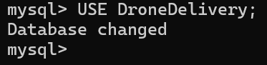

Query 2

SELECT *

FROM Drones

WHERE PayloadCapacity BETWEEN 5 AND 10;

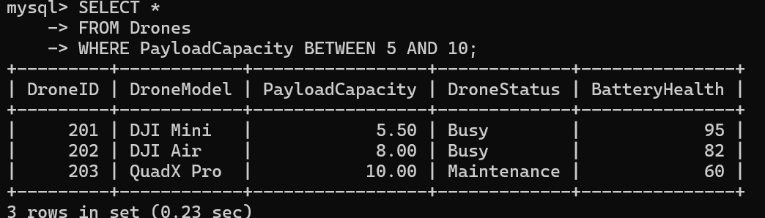

Query 3

SELECT *

FROM Deliveries

WHERE DeliveryID BETWEEN 301 AND 302;

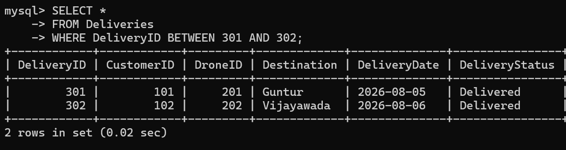

Query 4

SELECT *

FROM Customers

WHERE Address IN ('Hyderabad','Ongole');

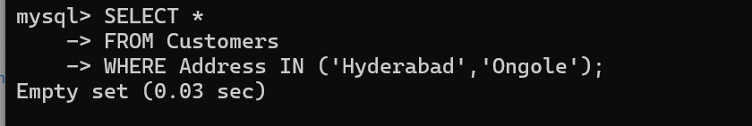

Query 5

SELECT COUNT(*) AS TotalCustomers

FROM Customers;

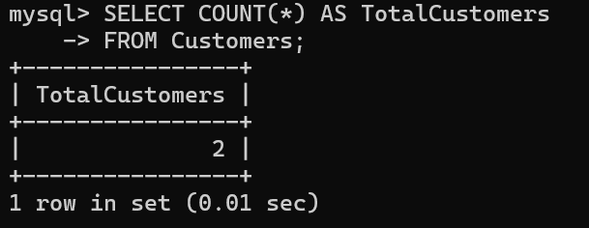

Query 6

SELECT SUM(PayloadCapacity) AS TotalCapacity

FROM Drones;

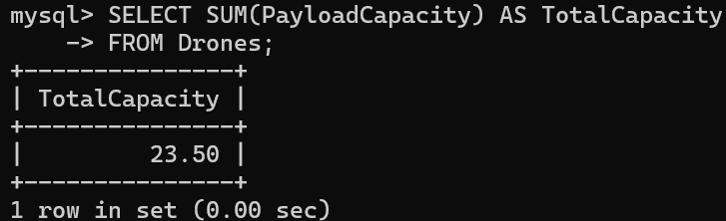

Query 7

SELECT AVG(PayloadCapacity) AS AverageCapacity

FROM Drones;

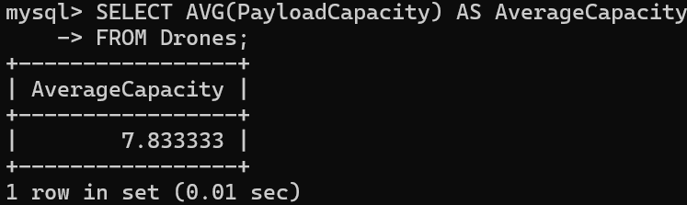

Query 8

SELECT MAX(PayloadCapacity) AS MaximumCapacity

FROM Drones;

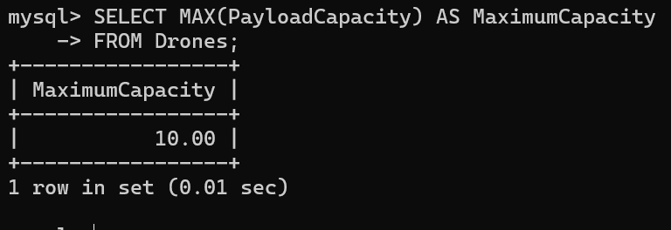

Query 9
SELECT MIN(PayloadCapacity) AS MinimumCapacity
FROM Drones;
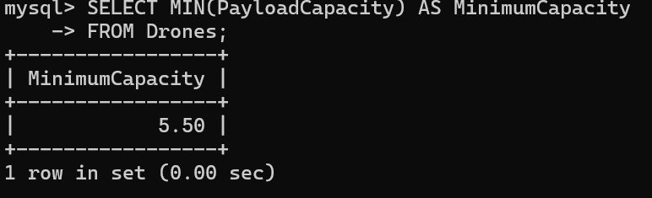

Query 10

SELECT COUNT(*) AS TotalDeliveries

FROM Deliveries;

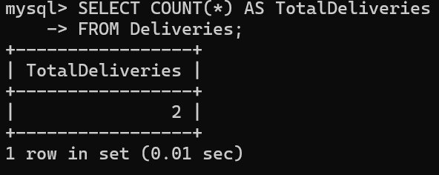

Query 11

SELECT AVG(BatteryHealth) AS AverageBattery

FROM Drones;

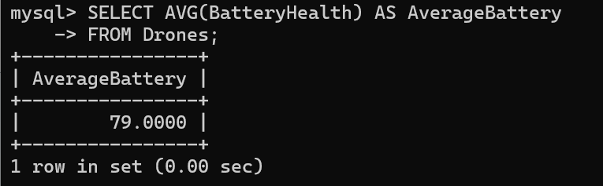

RESULT
Thus, the BETWEEN, IN, COUNT(), SUM(), AVG(), MIN(), and MAX() functions were successfully executed on the Drone Delivery Management System database.

